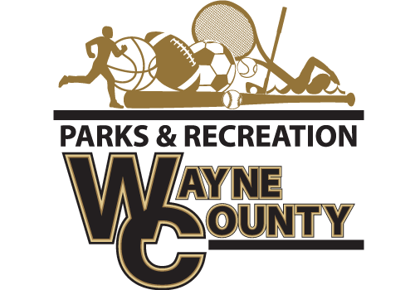400 Hinson Mosley Road, Jesup Ga 31545

Phone: 912-427-5915

Fax: 912-427-5945   
Recreation Director: Speck Echols

The Wayne County Recreation Department is accepting bids for 2024-2025 Basketball Jerseys.

**Requirements**

-Mesh Tank Top Reversible Jersey

-Must have all sizes available Youth to Adult XXL

Approximate Numbers for all leagues: 400

**Coaches Shirt Requirement**

**Approximate Number for coaches/assistant: 75**

-Augusta dri-fit brand-shirt with team name on front

All bids must be submitted no later than 10:00 a.m. on Friday, December 13, 2024. Bids will be opened promptly at that time. The winning bid will be awarded by 5:00 pm on Monday, December 16, 2024.

**Delivery Requirements:**

* All jerseys must be delivered no later than 5:00 p.m. on Monday, January 6, 2025.

**Submission Instructions:**

* Bids must be submitted in a sealed envelope clearly labeled: *Wayne County Recreation-BID*.
* Sealed bids should be delivered to:

Wayne County Commissioners Office

341 East Walnut Street

Attention: Amanda Hannah

Jesup, GA 31546

**Additional Information:**  
Wayne County reserves the right to:

* Reject any and all bids, with or without cause.
* Waive any informalities in the bidding process.
* Make awards in the best interest of Wayne County.

For questions or additional information, please contact the Recreation Department at

(912) 427-5915.