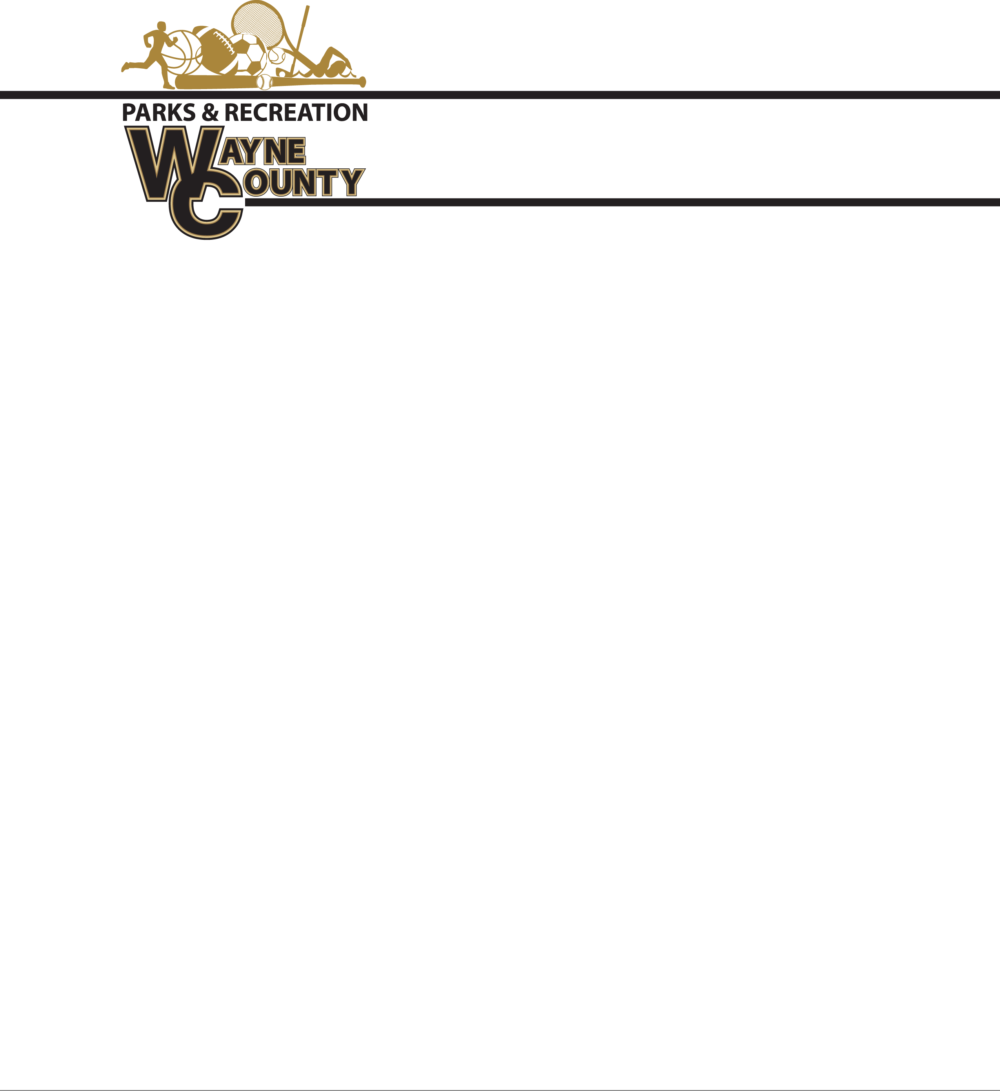

**Spring Baseball Shirt and Hat Bid**

MLB replica jersey shirts are 100 % Cotton MLB replica Jersey with matching hat or a Dri-fit replica jersey shirt and hat.

6” number pressed on back

Sponsor will be on back of shirt (Above and if needed below number)

Approximately 900 Youth Shirts and Hats $____________

Approximately 250 Adult Shirts and hats $_____________

**Coaches Shirts Replica MLB Replica with sponsor on back:**

Approximately 75 Coaches shirts and hats: $____________

Please specify if Cotton or Dri-fit: _________________________

Company Name:________________________________________

Signature________________________________ Date_______________________________

All bids must be submitted no later than 10:00 a.m. on Friday, January 31, 2025. Bids will be opened promptly at that time. The winning bid will be awarded by 5:00 pm on Monday, February 3, 2025.

Delivery Requirements:

* All uniforms and hats must be delivered no later than 12:00 p.m. on Friday, March 7, 2025.

Submission Instructions:

* Bids must be submitted in a sealed envelope clearly labeled: *Wayne County Recreation-BID*.
* Sealed bids should be delivered to:

Wayne County Commissioners Office

341 East Walnut Street

Attention: Amanda Hannah

Jesup, GA 31546

Additional Information:

Wayne County reserves the right to:

* Reject any and all bids, with or without cause.
* Waive any informalities in the bidding process.
* Make awards in the best interest of Wayne County.

For questions or additional information, please contact the Recreation Department at (912) 427-5915.